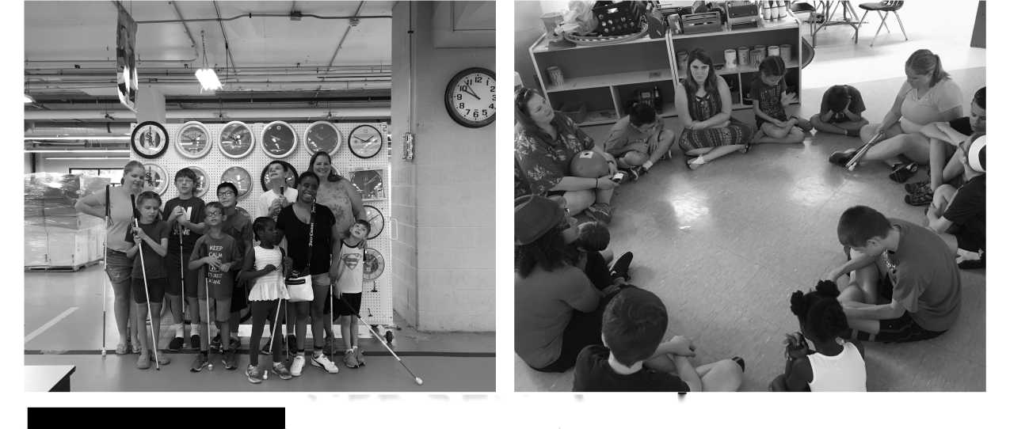
TOP TEN BELL
Ringers of 2018
10. Solarium
9. Mentors
8. Slate & Stylus
7. Playground
6. Drawing
Boards
5. Beep Kickball
4. Ice Cream
3. Walking Tacos
2. Judo
1. Kayaking

NFB OF ILLINOIS
BELL ACADEMY
BRAILLE ENRICHMENT FOR LITERACY AND LEARNING
NFB BELL Academy Chicago- Year 6
BRAILLE, NON-VISUAL AND TRAVEL SKILLS
"What is BELL?" is asked often. It is difficult to describe the awesomeness that is the NFB BELL Academy. The opportunity to reinforce, instruct and build braille skills is just a start. By setting high expectations, incorporating instruction and providing the opportunity to practice new skills, the participants grow exponentially. If you ask a participant, they may say it is like school but FUN. The program also relies on our mentors, successful blind adults, to model skills and show that independence is not only attainable but needed, so that they may live the lives they want, in their futures.
The teachers are so thankful for allowing us to work with your children this summer. We have enjoyed every moment of it! - Brooklyn Geers, Lauren Mehalek and Amy Lund
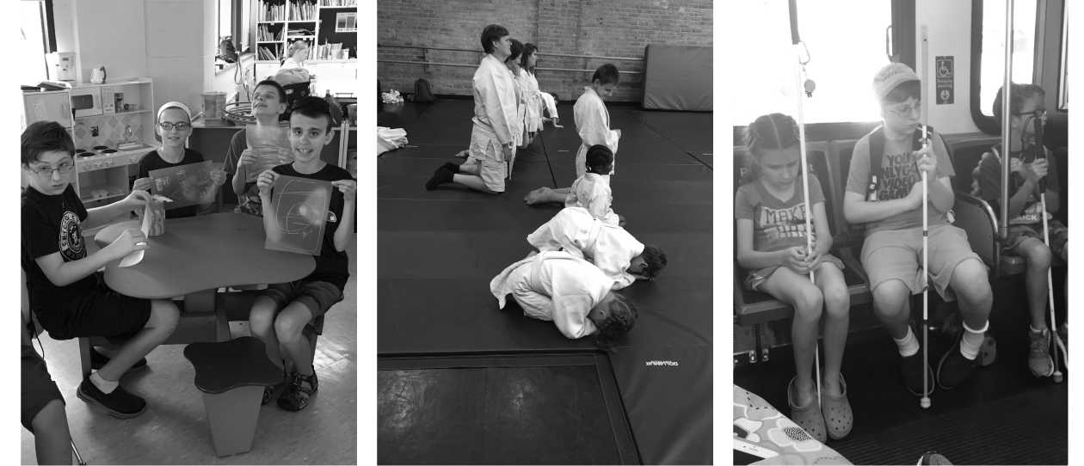

Please join us

NFB of Illinois State Convention
October 26-28 2018
Rosemont, Illinois
Fantastically Fun Field Trips
GROCERY STORE, BEEP KICKBALL, JUDO, KAYAKING

A major part of the NFB BELL Academy in Chicago are the amazing field trips. This summer we started off with a trip to the grocery store. Choosing the ingredients needed to make lunches for the next day was a big e responsibility. This trip also showed the mentors and teachers how well the participants followed directions and used their canes. A nice treat of ice cream was a great incentive as well.
The second trip was a short ride on the Pink Line to a beautiful park. We enjoyed a picnic lunch and played Beep Kickball. Everyone had a great time kicking and fielding the beeping ball.
New this year, we joined our Mentor Sara, while she taught all of us some Judo. Mentors and participants were able to warm up, learn different falls and then spar with a National Champion.
While not a trip off the grounds of the Chicago Lighthouse, we did enjoy touring the clock factory and Illinois Instructional Material Center. These great areas of the Lighthouse employ people who are blind or visually impaired as well as provide great services to our state and country.
Our final trip this summer was to the Chicago River, with Kayak Chicago. We enjoyed a beautiful day on the water while learning to maneuver our kayaks.

