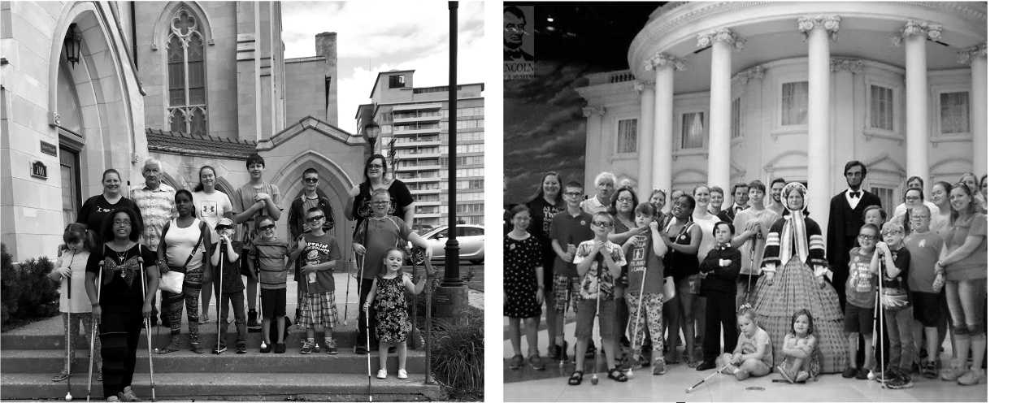

NFB OF ILLINOIS
BELL ACADEMY
BRAILLE ENRICHMENT FOR LITERACY AND LEARNING
NFB BELL Academy
TOP TEN BELL
Ringers of 2018
10. Yoga
9. Mentors
8. Slate & Stylus
7. Playground
6. Drawing
Boards
5. Beep Kickball
4. Hotel Pool
3. Cooking
2. New Friends
1. Walking Tacos
Springfield
BRAILLE, NON-VISUAL AND TRAVEL SKILLS
"What is BELL?" is asked often. It is difficult to describe the awesomeness that is the NFB BELL Academy. The opportunity to reinforce, instruct and build braille skills is just a start. By setting high expectations, incorporating instruction and providing the opportunity to practice new skills, the participants grow exponentially. If you ask a participant, they may say it is like school but FUN. The program also relies on our mentors, successful blind adults, to model skills and show that independence is not only attainable but needed, so that they may live the lives they want, in their futures.
The teachers are so thankful for allowing us to work with your children this summer. We have enjoyed every moment of it! -Lauren Mehalek and Amy Lund
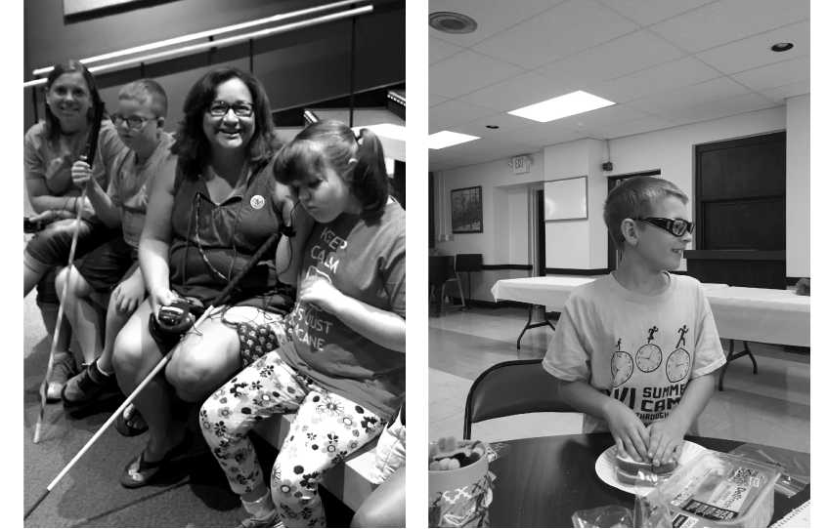
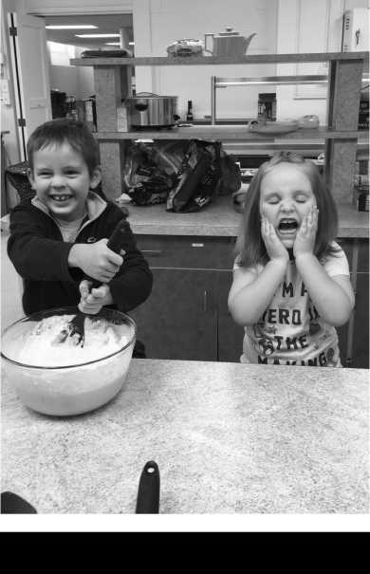

Please join us

NFB of Illinois State Convention
October 26-28 2018
Rosemont, Illinois
Fantastically Fun Week

What an exciting week filled with braille, cooking, extra cane practice, and so much more! In just a few short days, our wonderful kids have made so many meals using nonvisual skills. Each kid successfully made their own sandwich, some even got to try out a new spreading technique! Every child had the opportunity to either stir or measure when making our other lunches. Our perfectly mixed pancakes and macaroni and cheese were delicious!
New this year, BELL students earned money for the work that they completed and skills they used while at BELL. Everybody was in charge of locating and keeping track of their own money, identifying the coins in their bank using non-visual skills, and purchasing items in a store with their money.
Unfortunately for the kids (and fortunately for their learning), the bankers here at BELL are not very great and everybody had to really check their coins to make sure they were getting paid the correct amount and advocate for themselves if they were given the incorrect coins. The banks were a hit and the students really did an awesome job of managing their money!
Our awesome group took a field trip to the Abraham Lincoln Presidential Museum. While there, everyone was able to experience the life of Abraham Lincoln through his life's path. From childhood to his presidency, the kids and families were given an 'all access pass' to touch items most are never allowed to! The museum provided knowledgeable volunteers to help the groups learn more about each aspects of Lincoln's life. We had a great picnic lunch with the participants and families before our walk back to home base.

